OTA
- First, use the Bluetooth app to find the target device, and record the mac address of the device.
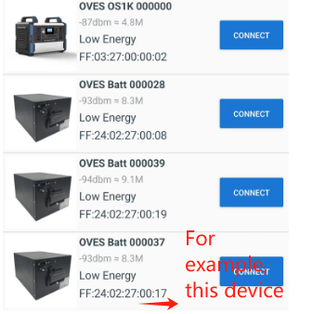

- Download the upgrade file from the specified location and save it to your cell phone


- Moving files to the root directory of the mobile file management system
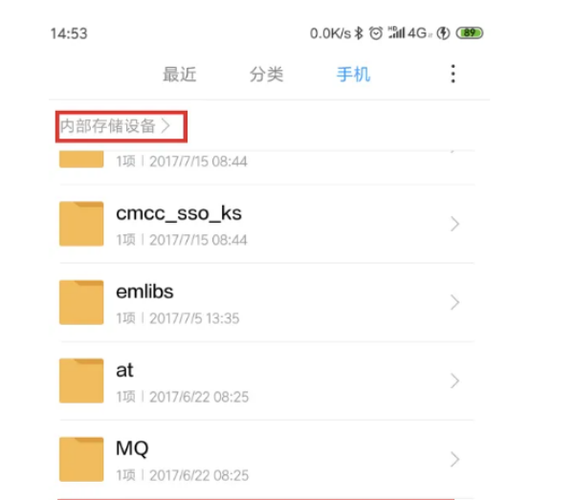

- After entering the upgrade app program, follow the previously recorded mac address to find the target device
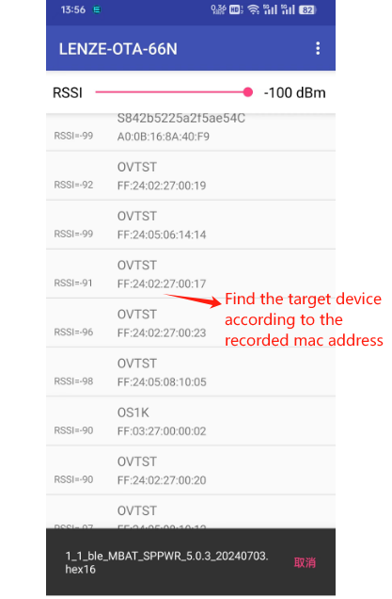

- Select the device and click enter, then select the upgrade file

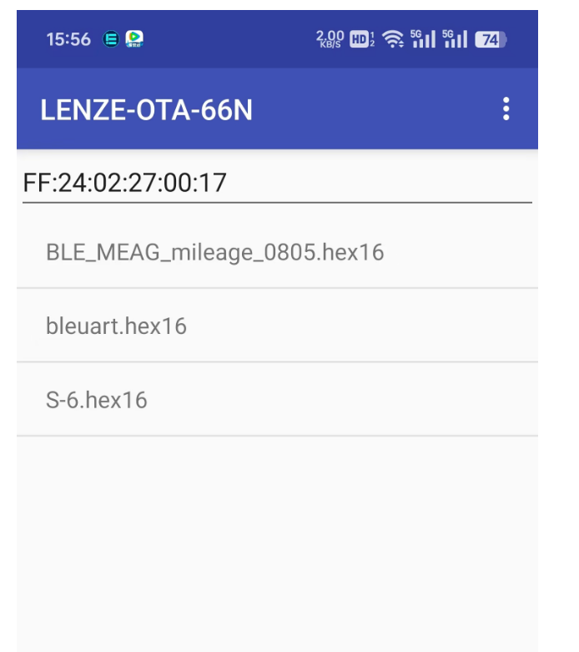

- Click on the device to enter the upgrade page ,If need a key, it's usually 0000000002.
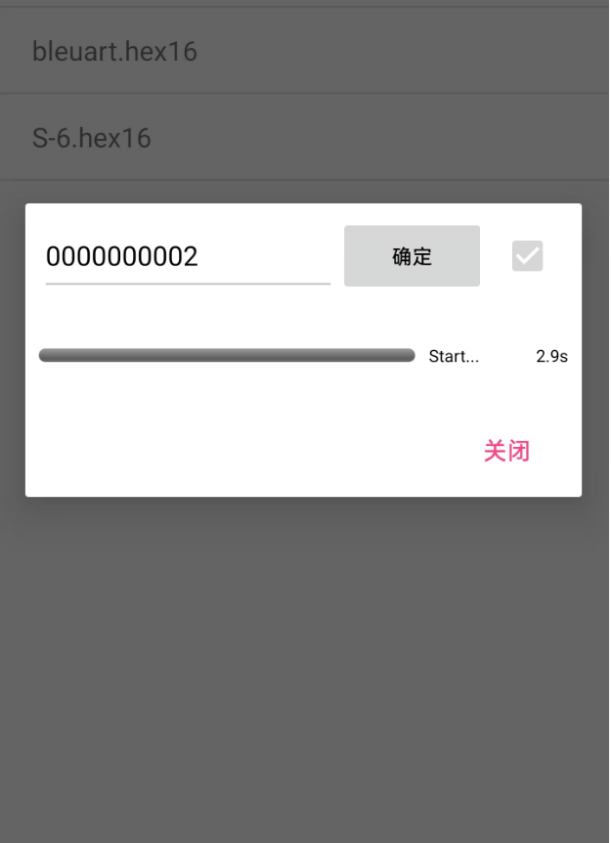

Note:If it fails, the name of the current device changes to PPlusOTA, and the mac address is incremented by 1.

Repeat the upgrade steps, but this time do not enter your password!

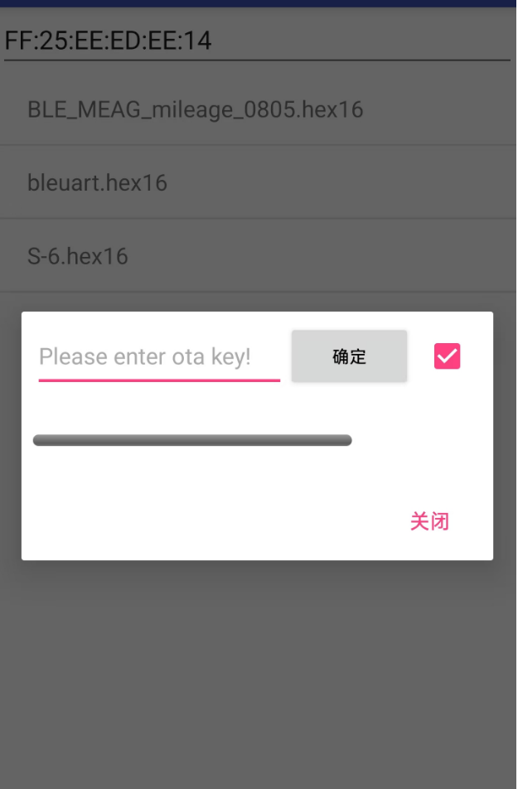

- Wait 12 seconds for the initialization and then the progress bar will start to change.
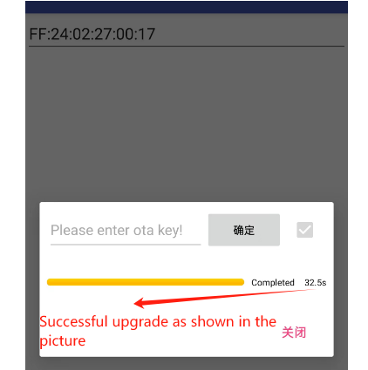

- Use the Bluetooth app to scan the target device and verify that the upgrade was successful.
